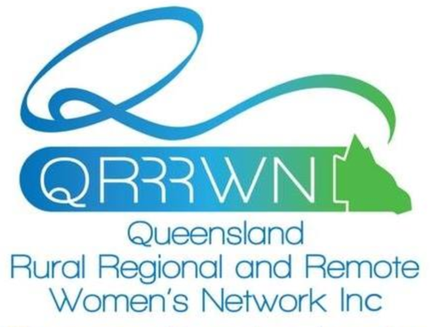
The QRRRWN Barambah Branch Bursary
2020 Bursary
The Barambah Network of the Queensland Rural, Regional and Remote Women’s Network (QRRRWN) are offering their annual bursary to provide support for women of the South Burnett Region who are looking to further their personal or business development.
The successful applicant will receive support of $1000 towards training of their choice.
To be eligible to apply for this bursary, you must be:
- A female resident of the South Burnett Region
- Over 30 years of age
- Seeking financial assistance to gain additional skills via training and personal or business development within the next 12 months
- Submit this application form before 30 November 2019
The successful applicant will be required to report, in person, to the QRRRWN Barambah Branch on their progress and use of the bursary within ten months of receiving the bursary.

PERSONAL DETAILS
Title: Given Names:
Family Name:
Regional Address:
Current Postal Address:
Telephone (H): Mobile:
Email Address:
Date of Birth: / /
Highest Education Level:
Year Completed:
Further Qualifications:

PERSONAL STATEMENT
In 350 words or less, please address the bursary criteria and help us learn a little about yourself. Please let us know:
- The reason for your application.
- How you meet all of the bursary criteria.
- What course/training you will use the bursary for with details including costs, dates etc.
- Your achievements in your studies and within your community.
- Your main interests and activities.
- Your future aspirations.
______________________________________________________________________________________________________________________________________________________________________________________________________________________________________________________________________________________________________________________________________________________________________________________________________________________________________________________________________________________________________________________________________________________________________________________________________________________________________________________________________________________________________________________________________________________________________________________________________________________________________________________________________________________________________________________________________________________________________________________________________________________________________________________________________________________________________________________________________________________________________________________________________________________________________________________________________________________________________________________________________________________________________________________________________________________________________________________________________________________________________________________________________________________________________________________________________________________________________________________________________________________________________________________________________________________________________________________________________________________________________________________________________________________________________________________________________________________________________________________________________________________________________________________________________________________________________________________________________________________________________________________________________________________________________________________________________________________________________________________________________________________________________________________________________________________________________________________________________________________________________________________________________________________________________

How did you hear about the QRRRWN Barambah Branch Bursary?

REFERENCES
Please provide the name and contact details of two referees. One of these referees should be someone who knows you in a professional or academic capacity.
1.) Name:
Organisation:
Position and Relationship to you:
Telephone:
2.) Name:
Organisation:
Position and Relationship to you:
Telephone:

Please complete the following checklist, then sign and submit your application.
Please check the following:
I am a South Burnett female
I am over 30 years of age
I have provided information regarding proposed training I am wishing to undertake in the next 12 months or am currently undertaking
I have completed the Personal Statement within this application form
APPLICATION CHECKLIST

SIGNED: ___________________________________________ Date: / /
SUBMIT YOUR APPLICATION – closes 30 November 2019. The successful recipient will be announced by Jan 2020.
- Email your completed application form to: info@redearth.org.au
- Post your completed application form to

QRRRWN Barambah Branch
c/- Red Earth Community Foundation
P.O Box 397
Kingaroy Qld 4610

Enquiries: Karen Seiler 0409 685 884
ALL APPLICATIONS WILL BE ACKNOWLEDGED – please contact us if you do not hear from us within 7 days when emailed, or 14 days when posted.
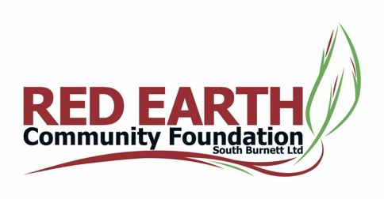
www.redearth.org.au
Proudly supported by

